**User/Admin Manual**

**System Menu**

The navigation bar of the system, it allows the user/admin to navigate to the different modules of the system. Each user would have a different navigation bar.



**Creating an Account to the System(ADMIN)**

Only the admin of the system can create an account to the system. The admin should encode the information needed and assign the role of the user.

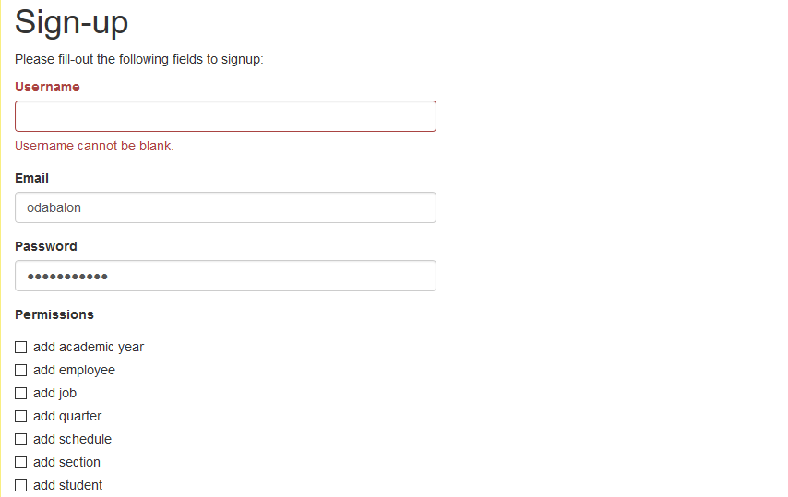

**Adding a Student Information(REGISTRAR)**

For the enrollment procedure, the Registrar would be encoding the information of the student and assign them to a section. Most of the information are needed to be filled out except for the Middle Name, Mother’s Name and Father’s Name. Then the Registrar would be assigning the student to a section.

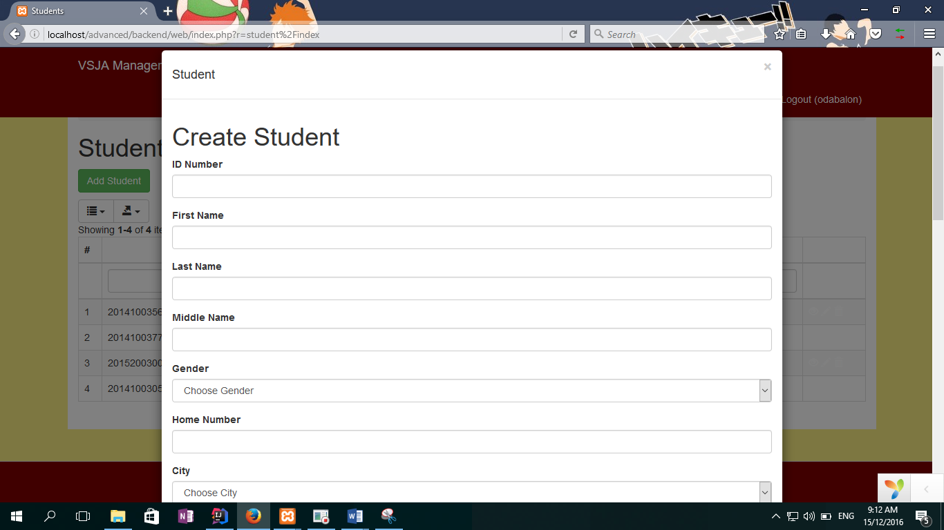

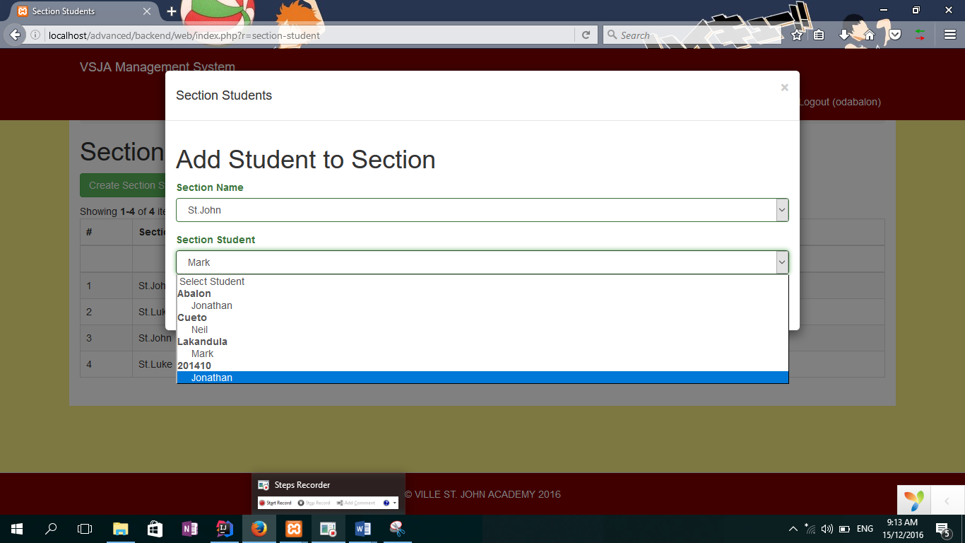

**Setting the Academic Year and Quarter(REGISTRAR)**

Before the School Year start, the Principal or the Registrar could assign the schedule of the current academic year. The schedule of each quarter in the academic year should also be defined.

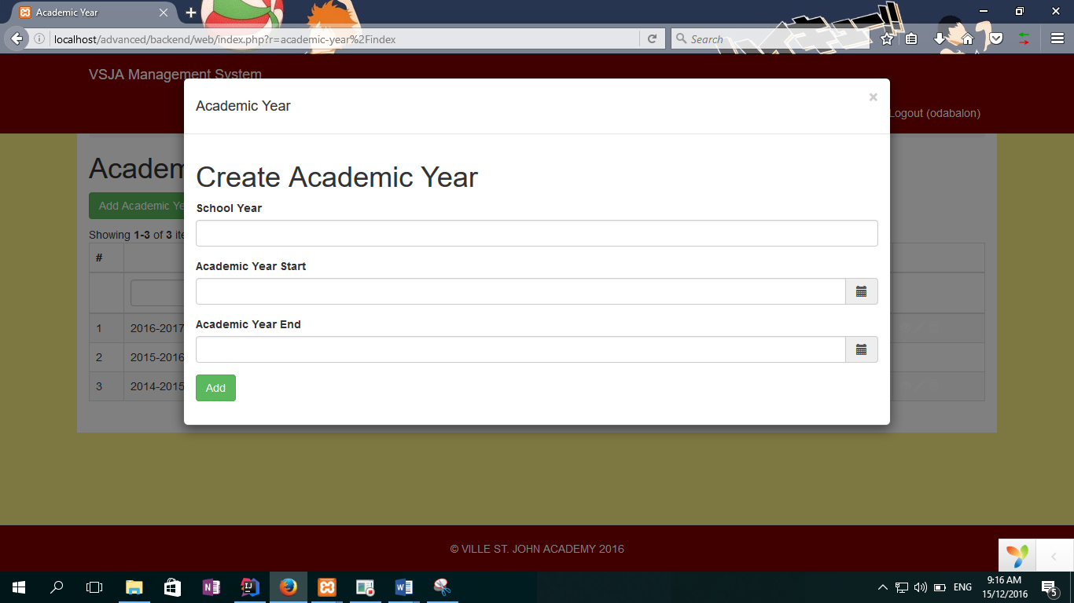

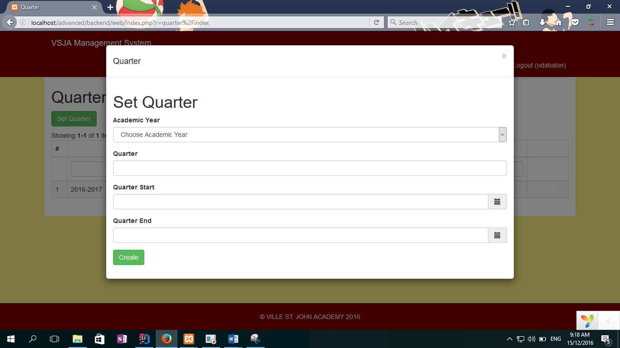

**Assigning a Schedule to a Teacher(DEPARTMENT HEAR)**

Once the academic year and the quarter schedule was already defined, the department head should assign each teacher a schedule.

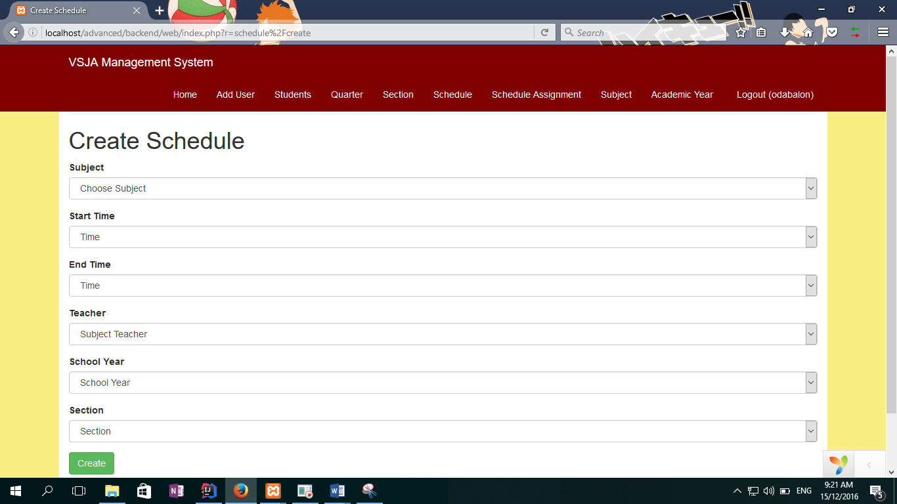

**Adding a Subject to the System (DEPARTMENT HEAD)**

For the department head, they could create a subject for the system.

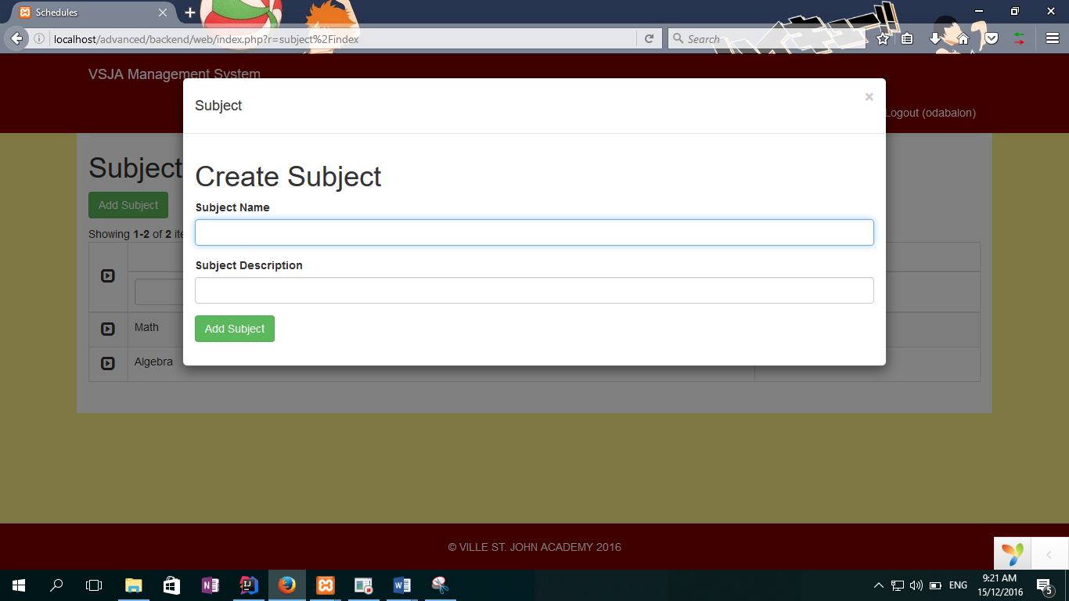

**Adding a Section to the System(REGISTRAR/DEPARTMENT HEAD)**

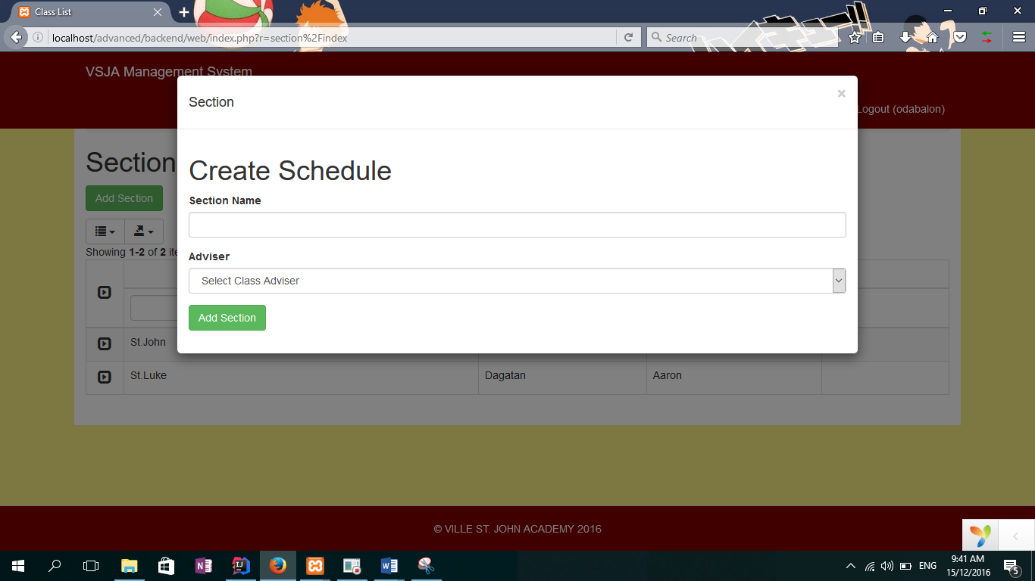

**Generating Excel File (List of Students)(REGISTRAR)**

The Registrar of the School could also export the list of students as an Excel file. The could select the information they want to be on the file.

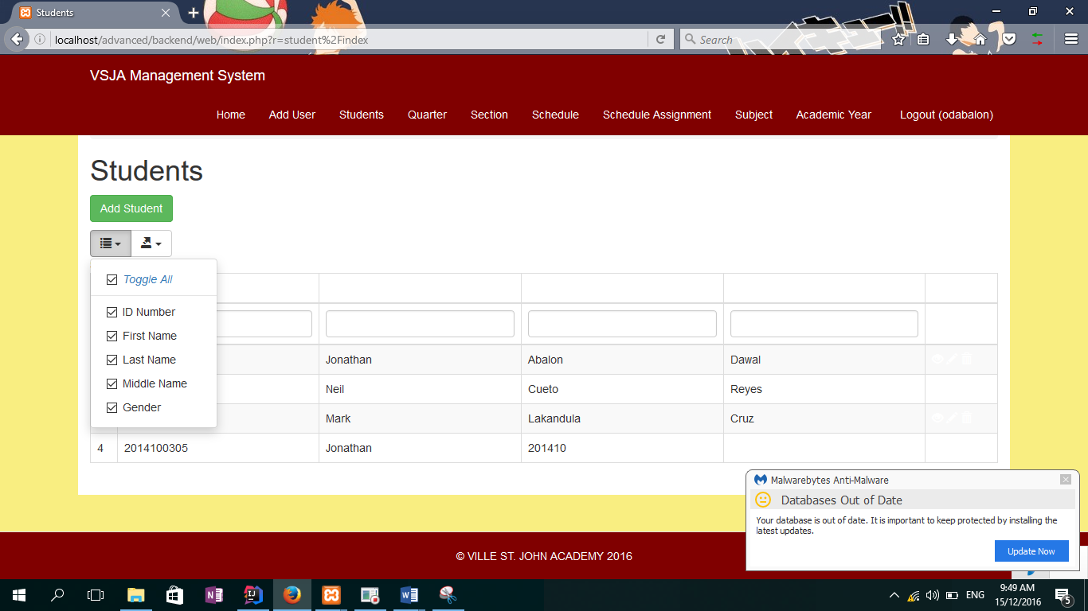

**Adding a Job (HR)**

The HR Department Head of the school could insert a job information in the system.

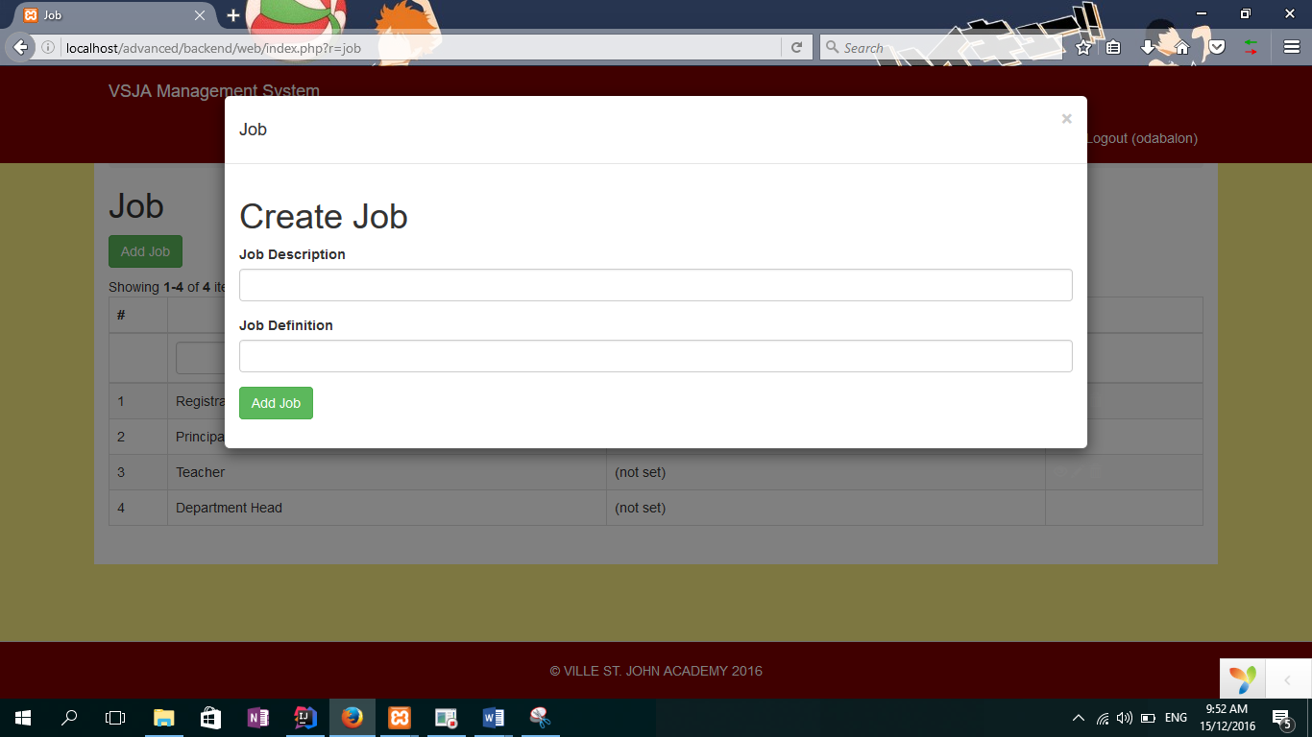

**Adding an Employee**

The HR Head could also add the employee’s information to the system and assign its job.

